***Name:Bijapure Naheen***

***R.No:08***

***Assignment-2***

***Q1. Design a web page of your department with an attractive background color, text color, Image etc. (use internal and external CSS).***

***Ans:***

***IT.html:***

*<!DOCTYPE html>*

*<html lang="en" dir="ltr">*

*<head>*

*<meta charset="utf-8">*

*<title>Information Technology</title>*

*<link rel="stylesheet" href="xyz.css" type="text/css">*

*<style type="text/css">*

*.vid{font-family:verdana;font-style:italic;color:red;text-align:center;font-size:40px;}*

*.ani{font-family:tahoma;font-style:italic;font-size:20;text-align:center;}*

*font{font-family:georgia;color:blue;font-size:20}*

*mark{*

*background-color:yellow;*

*color:red;*

*}*

*table,th,tr,td{*

*border:1px solid;*

*}*

*</style>*

*</head>*

*<body class="body">*

*<h2 class="vid"><mark>Walchand Institute Of Technology,Solapur</mark></h2>*

*<p style="text-align:center;color:purple;font-size:30px">The Institute is affiliated to the Solapur University, Solapur and approved by the All India Council for Technical Education, New Delhi (A.I.C.T.E., New Delhi.).</p>*

*<br>*

*<img src="wit.jpg" alt="WIT" style="width:100%">*

*<br>*

*<div class="d1">*

*<ul class="Departments">*

*<br>*

*<details style="text-align:center">*

*<summary style="color:red;text-align:center"><mark>Departments:</mark></summary>*

*<br>*

*<li style="font-size:20px">CSE</li>*

*<li style="font-size:20px">IT</li>*

*<li style="font-size:20px">E&TC</li>*

*<li style="font-size:20px">Electronics</li>*

*<li style="font-size:20px">Civil</li>*

*<li style="font-size:20px">Mechanical</li>*

*</ul>*

*</div>*

*<br>*

*<h2 class="vid"><mark>Information Technology</mark></h2>*

*<details style="text-align:center">*

*<summary style="color:green;text-align:center;font-size:30px"><mark>Faculty</mark></summary>*

*<br>*

*<table class="faculty">*

*<tr>*

*<th>Faculty</th>*

*<th>Information</th>*

*</tr>*

*<tr>*

*<td style="margin-left:10px"><img src="lobo.jpg" alt="lobo sir"></td>*

*<td>*

*Mr.L.M.R.J Lobo*

*Associate Professor*

*Qualification :M.Tech(CSE) IIT Kharagpur, PhD\**

*Area of Specialisation : Data Minig & Genetic Algorithm*

*Experience :*

*1.Teaching : 28Years*

*2.Industry 9 Years ( Industry Interaction)*

*3.Research :12 Years*

*E-Mail:headitwit@gmail.com*

*</td>*

*</tr>*

*<tr>*

*<td><img src="nirgude.jpg" alt="nirgude mam"></td>*

*<td>*

*Mrs. M. A. Nirgude*

*Assistant Professor*

*Qualification :M.E.(Computer),Ph.D(CSE)in progress*

*Area of Specialisation : Databases, Information Retrieval, Image Processing*

*Experience :*

*1.Teaching :15 years*

*2.Industry :5 years*

*3.Research :5*

*</td>*

*</tr>*

*<tr>*

*<td><img src="kathavte.jpg" alt="kathavte sir" width="200px" height="170px"></td>*

*<td>*

*Mr. P. N. Kathavate*

*Assistant Professor*

*Qualification :B.E.(CSE), M.E.(Computer Engineering)*

*Area of Specialisation : Databases, Software Engineering*

*Experience :*

*1.Teaching :13 Years*

*2.Research :2 Years*

*E-Mail:pravin.kathavate@gmail.com*

*</td>*

*</tr>*

*<tr>*

*<td><img src="dipali.jpg" alt="dipali mam" width="200px" height="170px"></td>*

*<td>*

*MS. D.D. Awasekar*

*Assistant Professor*

*Qualification :B.E.(IT), M.E.(CSE)*

*Area of Specialisation : Networking, System Programming,Education Technology*

*Experience :*

*1.Teaching :10 Years*

*1.Research :2 Years*

*E-Mail:dipali.awasekar@gmail.com*

*</td>*

*</tr>*

*</table>*

*</body>*

*</html>*

***xyz.css:***

*.Departments{*

*display: inline-block;*

*text-align: left;*

*}*

*.d1{*

*text-align: center;*

*font-size:30px;*

*}*

*.body{*

*background-color:#f0ffff;*

*}*

***Output:***

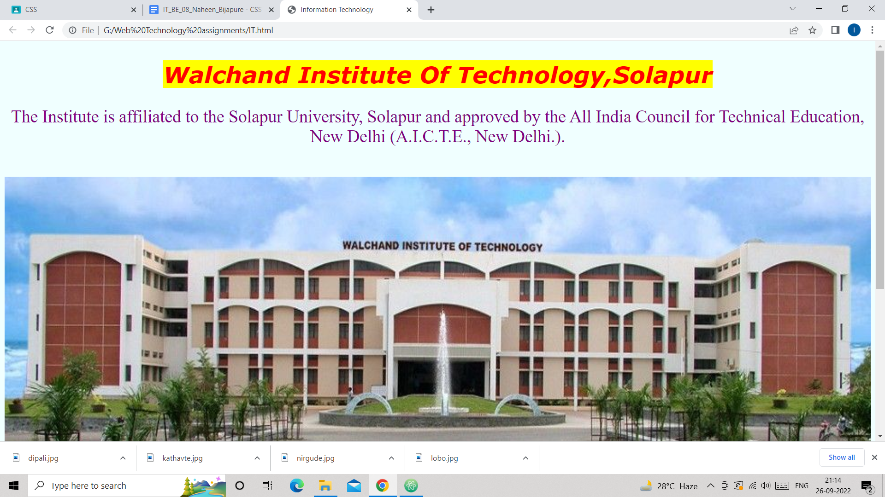

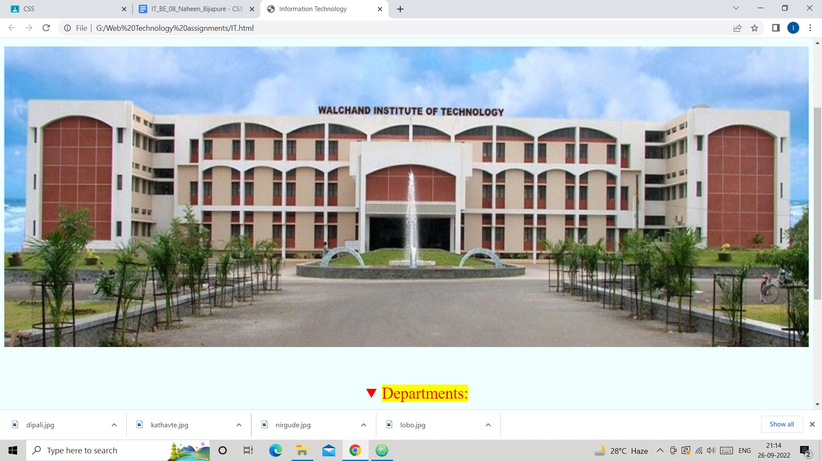

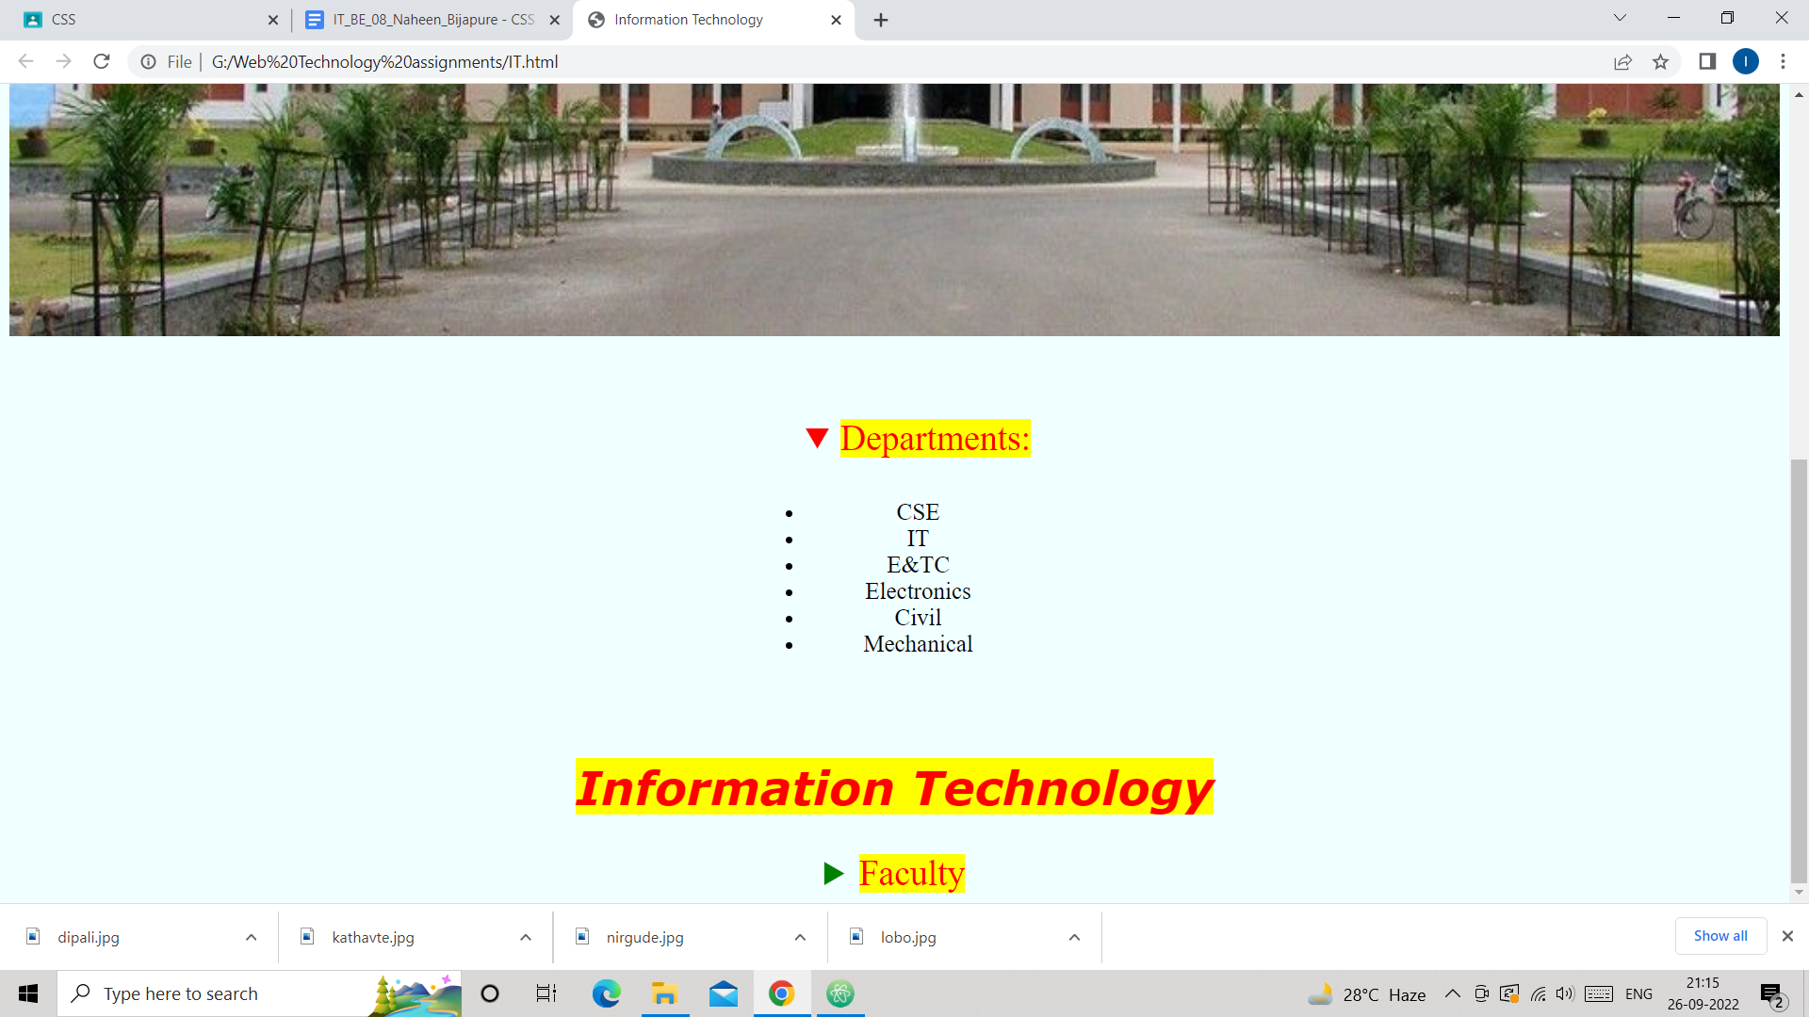

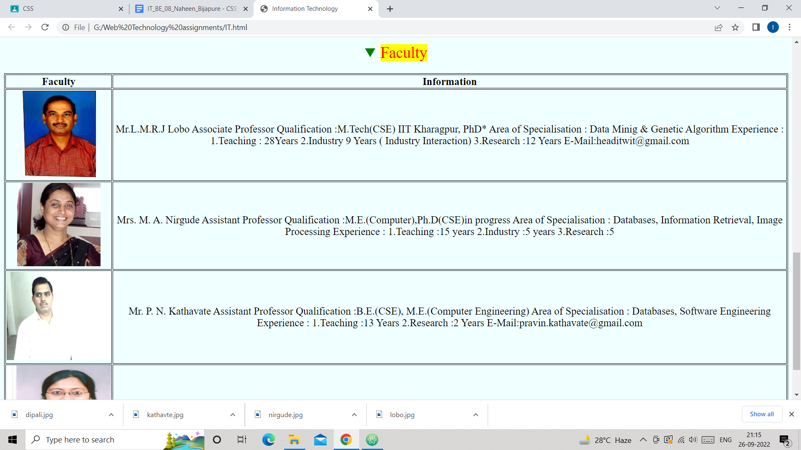

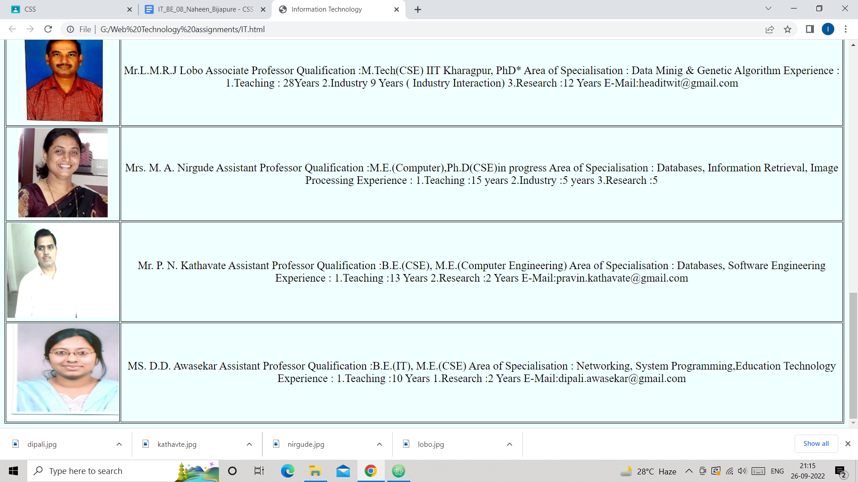

***Q2.Use CSS3 2D transform feature to transform in 2D space.***

***Ans:***

***2D.html:***

*<!DOCTYPE html>*

*<html lang="en" dir="ltr">*

*<head>*

*<meta charset="utf-8">*

*<title>2D transformation</title>*

*<link rel="stylesheet" href="transform1.css">*

*<style>*

*div{*

*width:300px;*

*height:100px;*

*background-color:yellow;*

*border:2px solid black;*

*}*

*</style>*

*</head>*

*<body>*

*<h1>The translate() Method</h1>*

*<p>The translate() method translates an element.</p>*

*<div>*

*This a normal div element.*

*</div>*

*<div id="c1">*

*This div translates.*

*</div>*

*<hr>*

*<h1>The rotate() Method</h1>*

*<p>The rotate() method translates an element.</p>*

*<div>*

*This is Normal Div.*

*</div>*

*<div id="c2">*

*This is rotated div.*

*</div>*

*<hr>*

*<h1>The scale() Method</h1>*

*<p>The scale() method resize the element.</p>*

*<div>*

*This is Normal Div.*

*</div>*

*<div class="c3">*

*This is scaled div.*

*</div>*

*<br>*

*<br>*

*<hr>*

*<h1>The rotate() Method</h1>*

*<p>The rotate() method translates an element in anti-clickwise direction.</p>*

*<div>*

*This is Normal Div.*

*</div>*

*<div id="c4">*

*This is rotated div in anti-clockwise direction.*

*</div>*

*<br>*

*<br>*

*<br>*

*<br>*

*<hr>*

*<h1>The scaleX() Method</h1>*

*<p>The scaleX() method resize an element according to x-axis.</p>*

*<div>*

*This is normal div.*

*</div>*

*<div class="c5">*

*This is scaleX() applied div.*

*</div>*

*<br>*

*<br>*

*<br>*

*<br>*

*<hr>*

*<h1>The scaleY() Method</h1>*

*<p>The scaleY() method resize an element according to y-axis.</p>*

*<div>*

*This is normal div.*

*</div>*

*<div class="c6">*

*This is scaleY() applied div.*

*</div>*

*<br>*

*<br>*

*<br>*

*<br>*

*<hr>*

*<h1>The skew() Method</h1>*

*<p>The skew() method skews an element along the X and Y-axis by the given angles.</p>*

*<div>*

*This is normal div.*

*</div>*

*<div class="c7">*

*This is skew() applied div.*

*</div>*

*<br>*

*<br>*

*<br>*

*<br>*

*<hr>*

*<h1>The skewX() Method</h1>*

*<p>The skewX() method skews an element along the X-axis by the given angles.</p>*

*<div>*

*This is normal div.*

*</div>*

*<div class="c8">*

*This is skewX() applied div.*

*</div>*

*<br>*

*<br>*

*<br>*

*<br>*

*<hr>*

*<h1>The skewY() Method</h1>*

*<p>The skewY() method skews an element along the Y-axis by the given angles.</p>*

*<div>*

*This is normal div.*

*</div>*

*<div class="c9">*

*This is skewY() applied div.*

*</div>*

*<br>*

*<br>*

*<br>*

*<br>*

*<hr>*

*<h1>The matrix() Method</h1>*

*<p>The matrix() method combines all the 2D transform methods into one.</p>*

*<div>*

*This is normal div.*

*</div>*

*<div id="c10">*

*This is matrix() applied div.*

*</div>*

*</body>*

*</html>*

***transform.css:***

*#c1{*

*transform: translate(100px,10px);*

*}*

*#c2{*

*transform: rotate(45deg);*

*}*

*.c3{*

*transform: scale(2,2);*

*}*

*#c4{*

*transform: rotate(-90deg);*

*}*

*.c5{*

*transform: scaleX(2);*

*}*

*.c6{*

*transform: scaleY(0.5);*

*}*

*.c7{*

*transform: skew(20deg,5deg);*

*}*

*.c8{*

*transform: skewX(45deg);*

*}*

*.c9{*

*transform: skewY(25deg);*

*}*

*#c10{*

*transform: matrix(1, 0, 0.5, 1, 150, 0);*

*}*

***Output:***

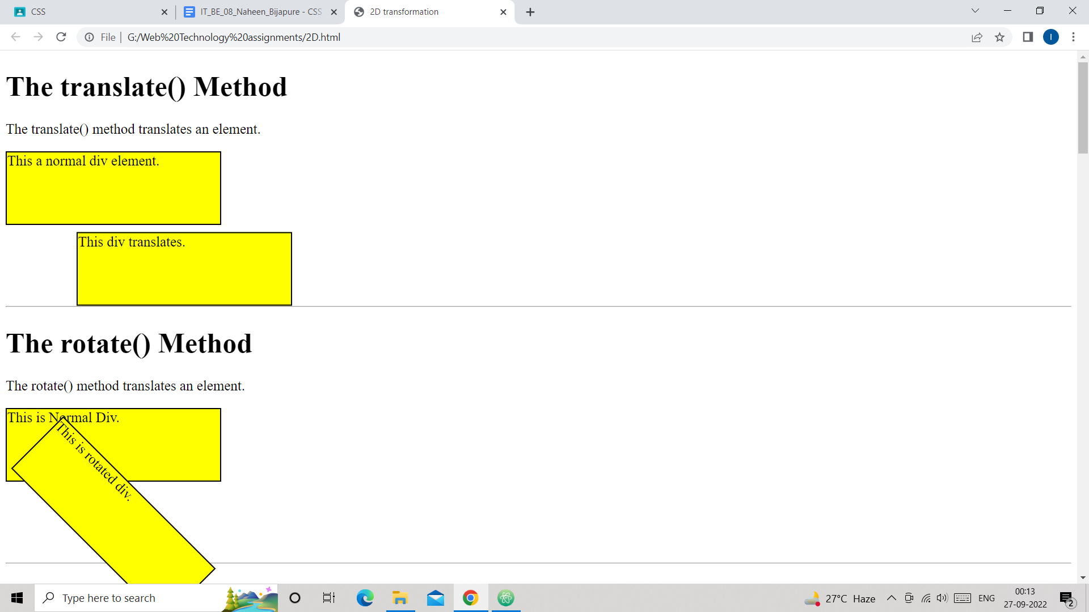

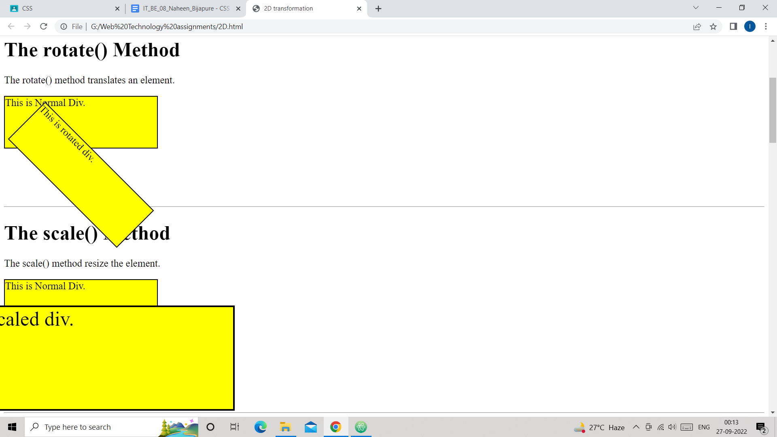

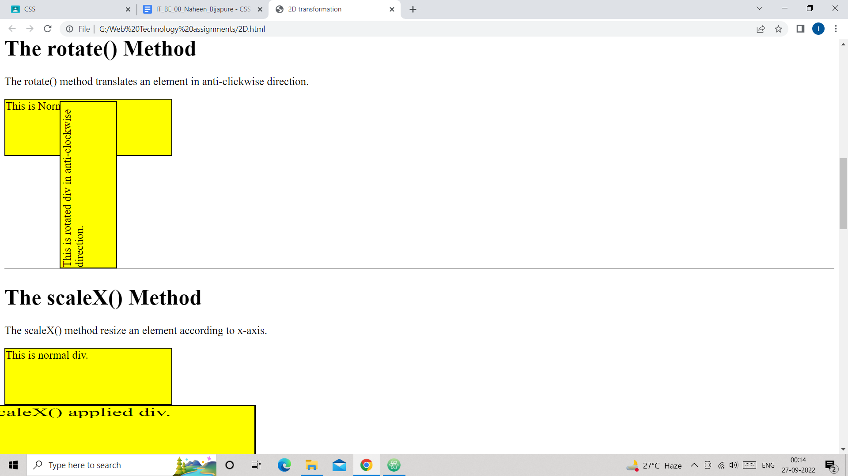

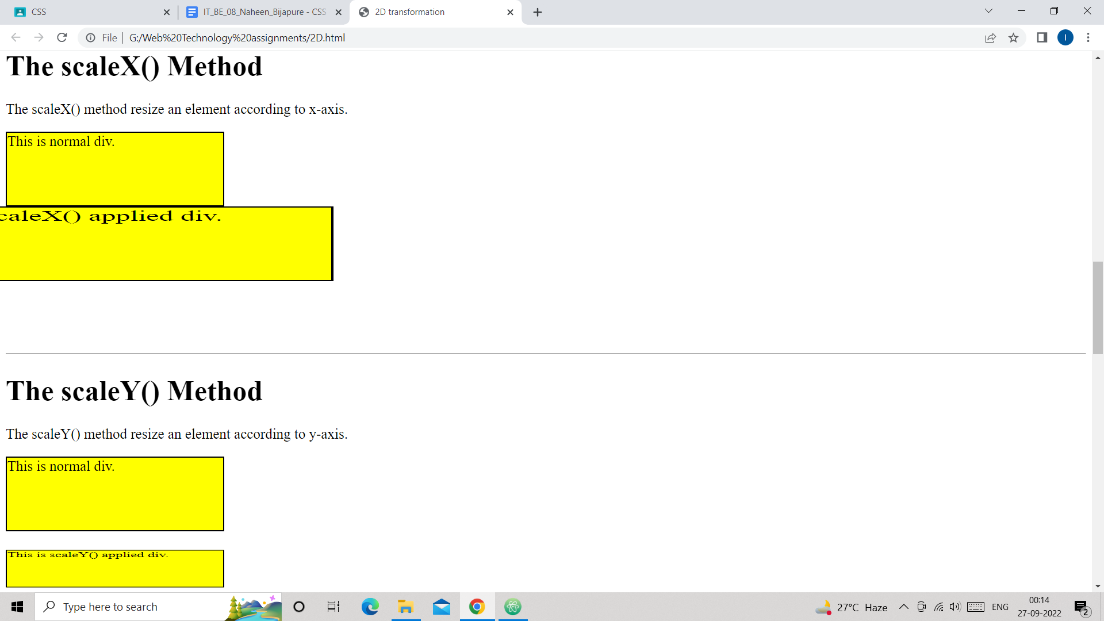

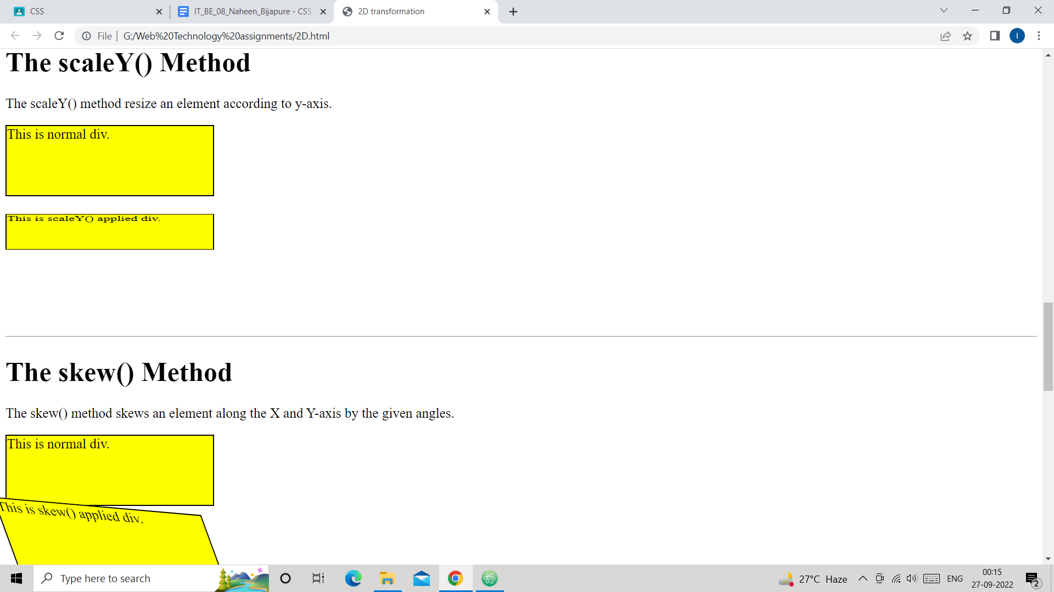

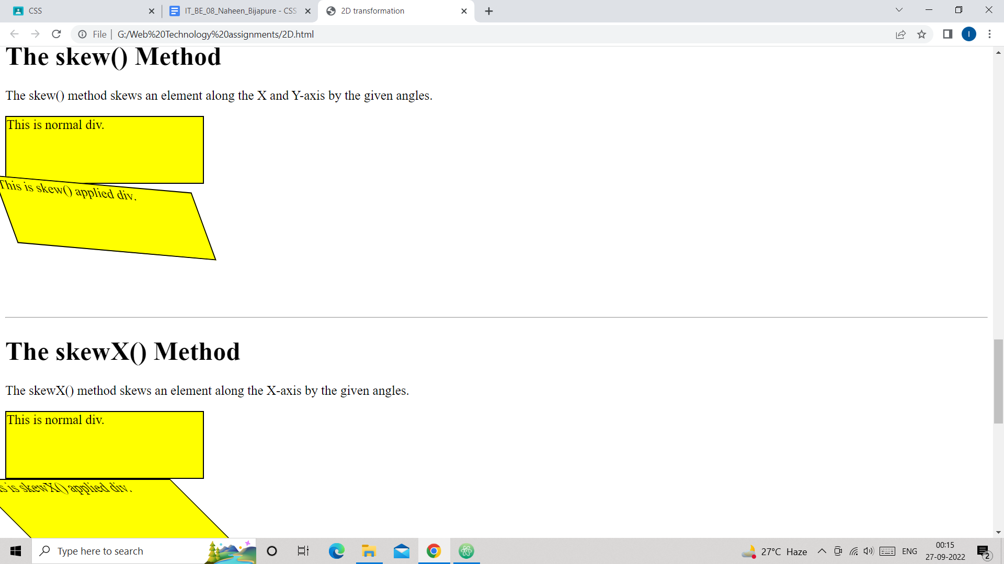

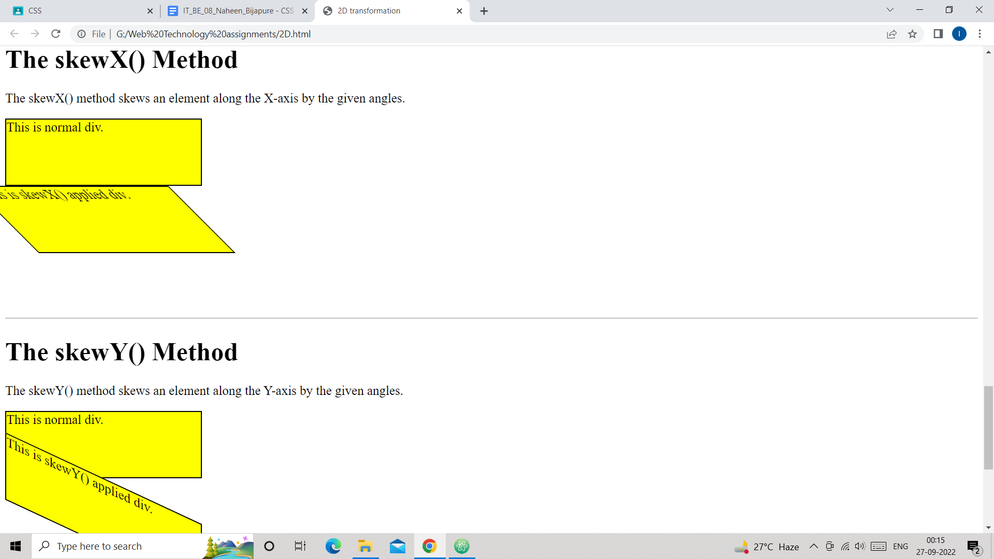

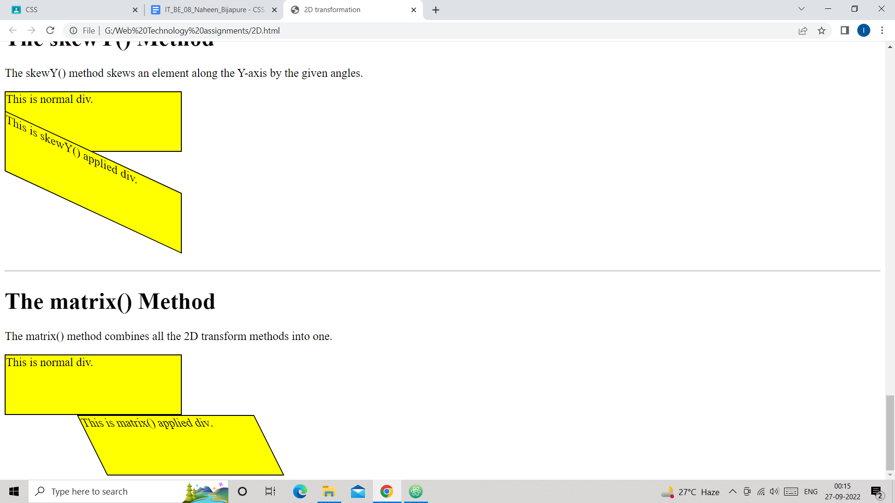

***Q3.Use CSS3 3D transform feature to transform in 3D space.***

***Ans:***

***3D.html:***

*<!DOCTYPE html>*

*<html lang="en" dir="ltr">*

*<head>*

*<meta charset="utf-8">*

*<title>3D Transformation</title>*

*<link rel="stylesheet" href="transform2.css">*

*<style>*

*div{*

*width:300px;*

*height:100px;*

*background-color:purple;*

*border:1px solid black;*

*}*

*</style>*

*</head>*

*<body>*

*<h2>3D Rotation:</h2>*

*<div>*

*This is normal div.*

*</div>*

*<div class="rotate3d">*

*This is 3D rotated div by 25 degree.*

*</div>*

*<br>*

*<br>*

*<hr>*

*<h2>3D Scaling:</h2>*

*<div>*

*This is normal div.*

*</div>*

*<div class="scale3d">*

*This is 3d scaled div.*

*</div>*

*<br>*

*<br>*

*<hr>*

*<h2>3D Translation:</h2>*

*<div>*

*This is normal div.*

*</div>*

*<div class="trasnlate3d">*

*This is 3d Tarnslated div.*

*</div>*

*</body>*

*</html>*

***transform2.css:***

*.rotate3d{*

*transform: rotate3d(10,50,30,25deg);*

*}*

*.scale3d{*

*transform: scale3d(0.5,1,0.25);*

*}*

*.trasnlate3d{*

*transform: translate3d(0.5,5,60);*

*}*

***Output:***

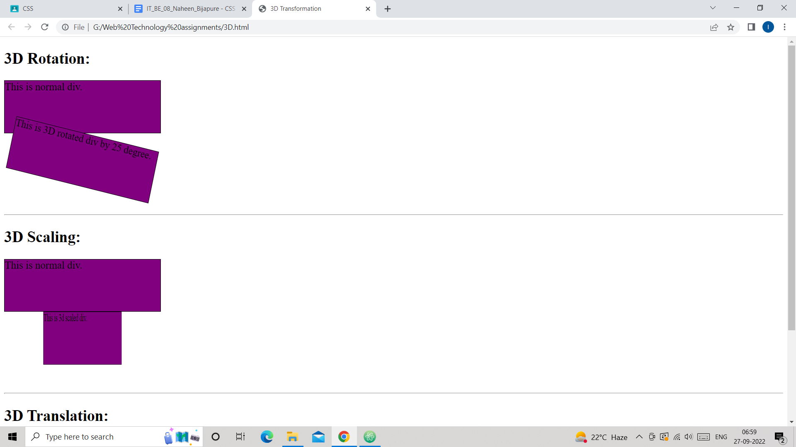

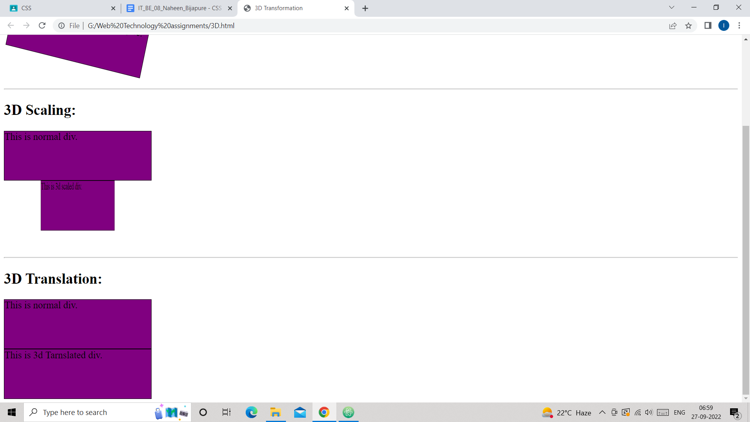

***Q4.Use CSS3 transition feature which allows the changes in CSS property values to occur smoothly over a specified duration.***

***Ans:***

*<!DOCTYPE html>*

*<html lang="en" dir="ltr">*

*<head>*

*<meta charset="utf-8">*

*<title>Transition</title>*

*<style media="screen">*

*div{*

*width:200px;*

*height:200px;*

*background-color:yellow;*

*border:1px solid black;*

*transition:width 2s,height 2s,transform 2s;*

*transition-delay:1s;*

*transition-duration:3s;*

*transition-timing-function:linear;*

*}*

*div:hover{*

*width:300px;*

*height:300px;*

*transform:rotate(-360deg);*

*}*

*</style>*

*</head>*

*<body>*

*<h2>Transition Demo</h2>*

*<div class="d1">*

*This div is going to rotate by 360 degree in anti-clockwise direction.*

*</div>*

*</body>*

*</html>*

***Output:***

***After placing mouse on div:***

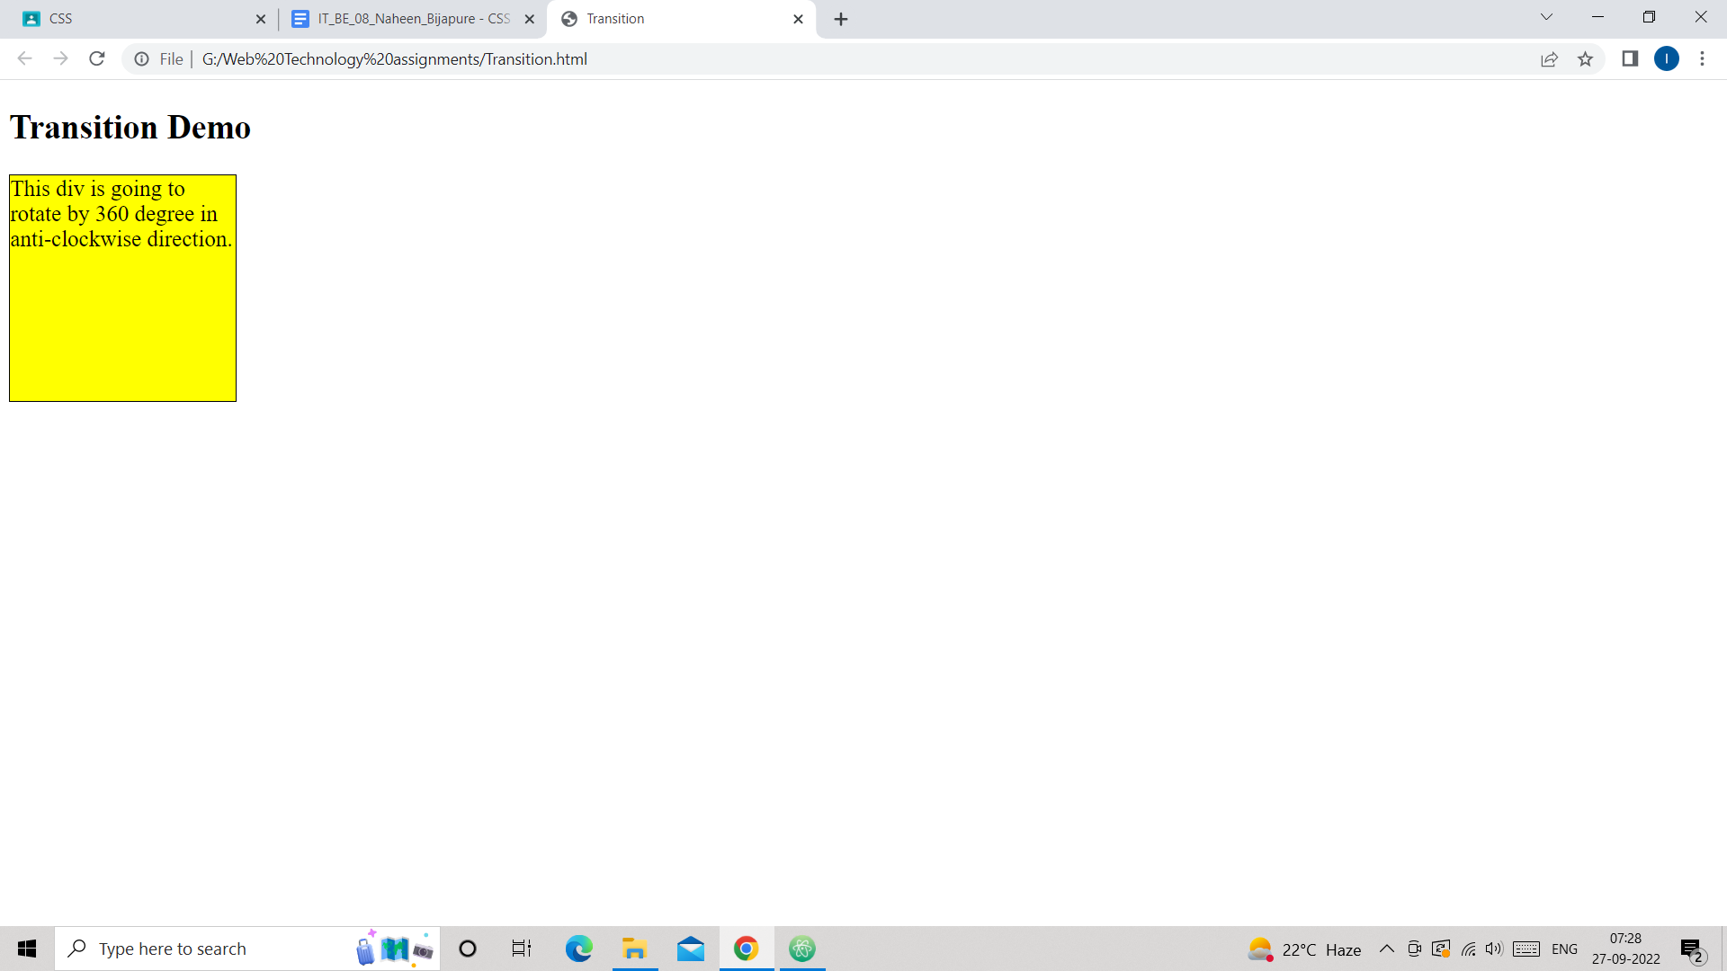

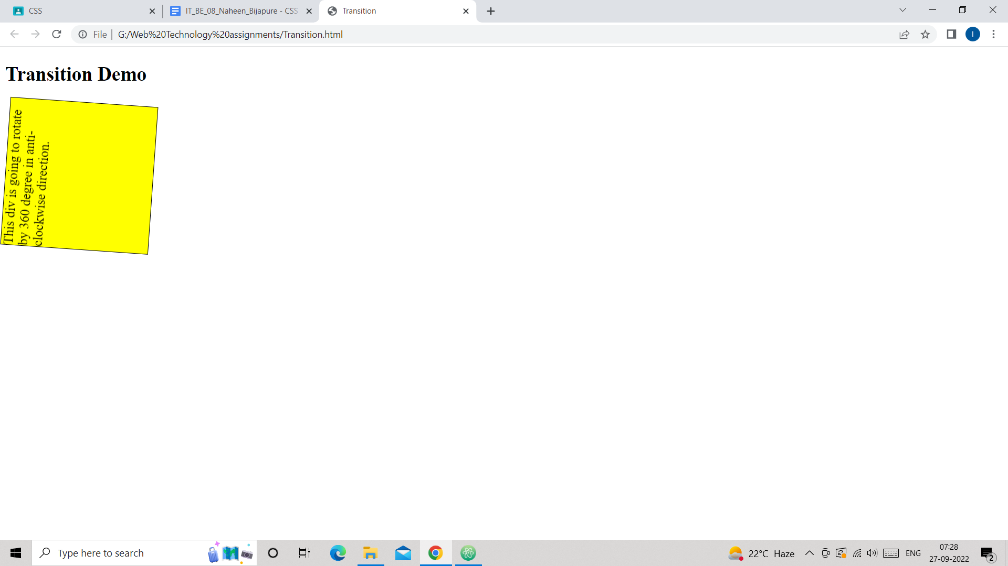

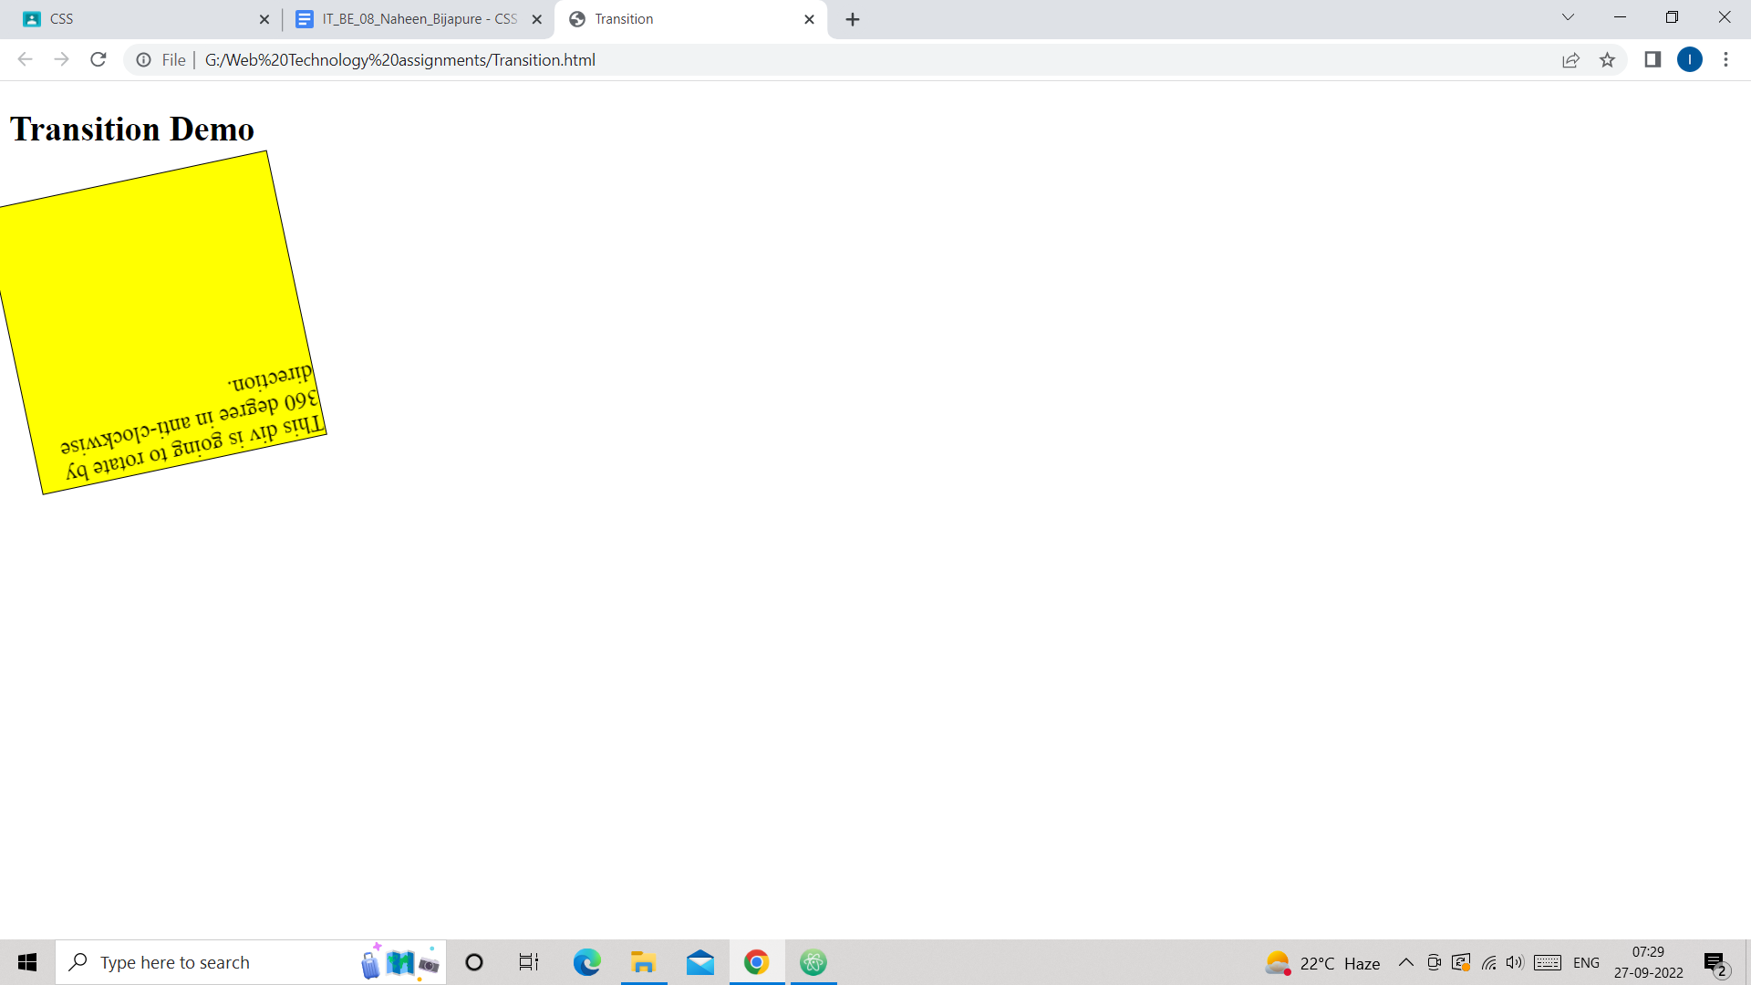

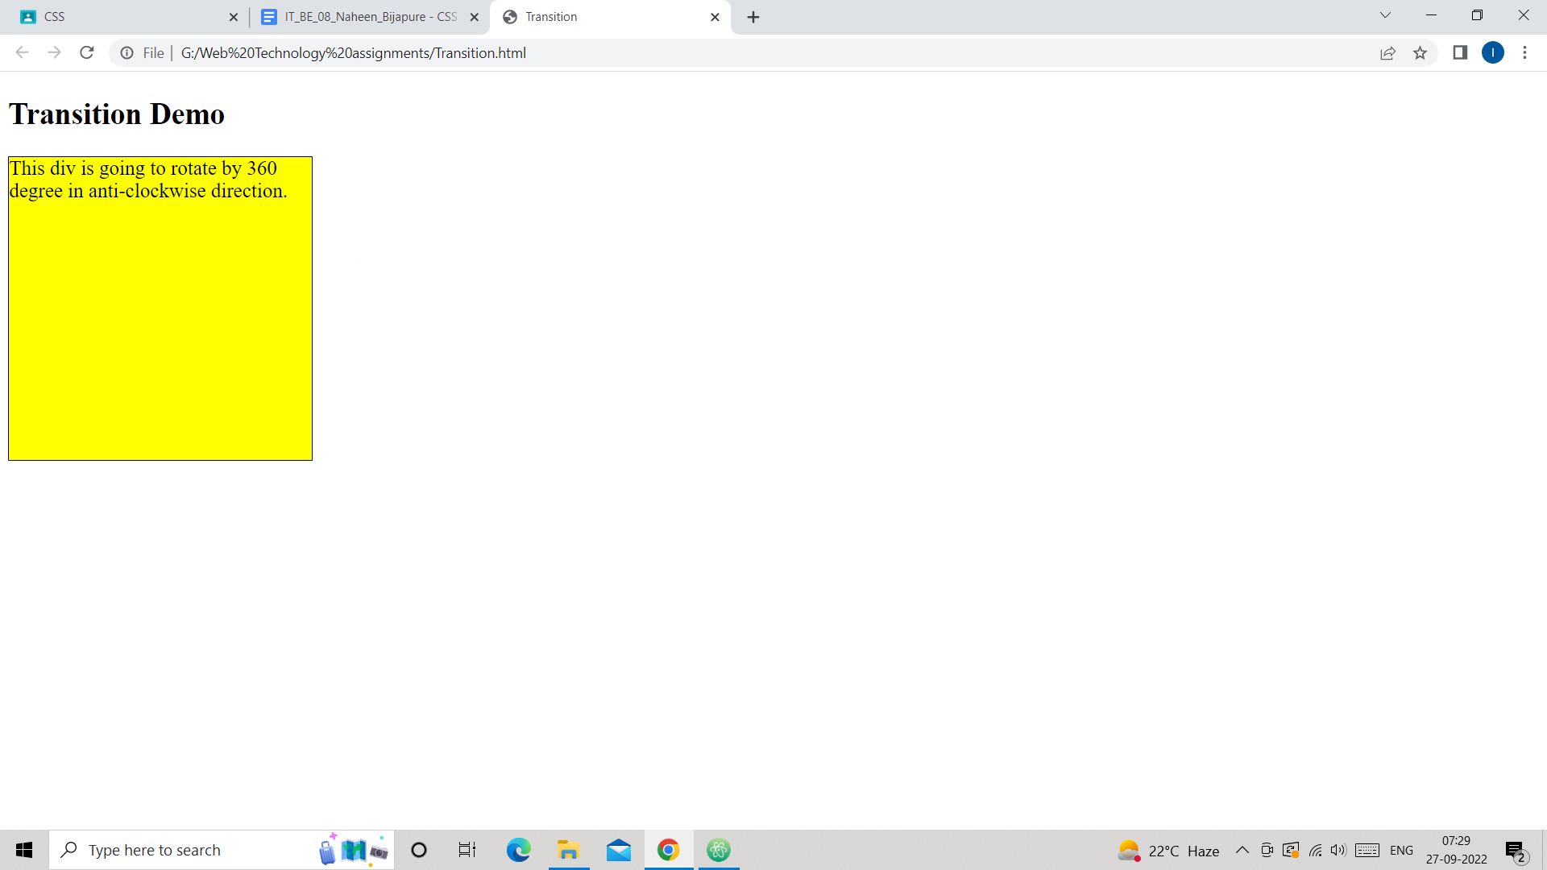

***After removing mouse from div:***

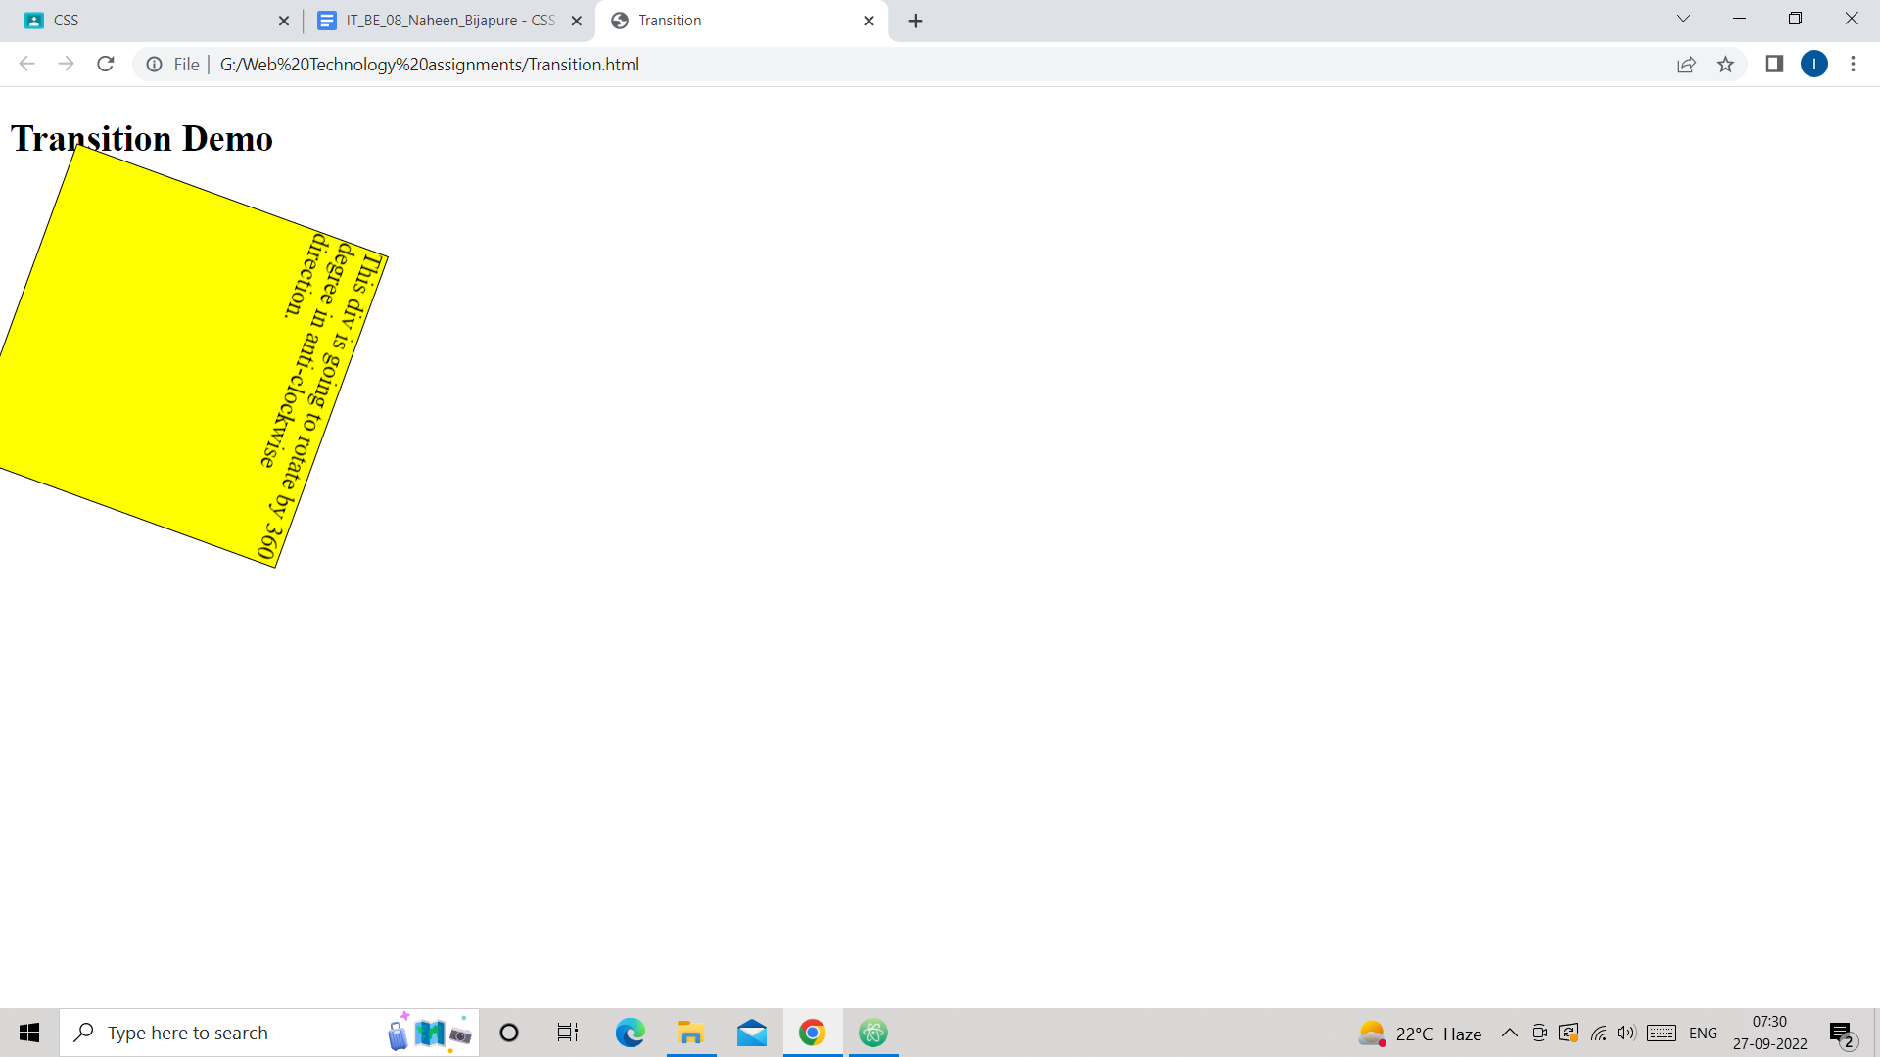

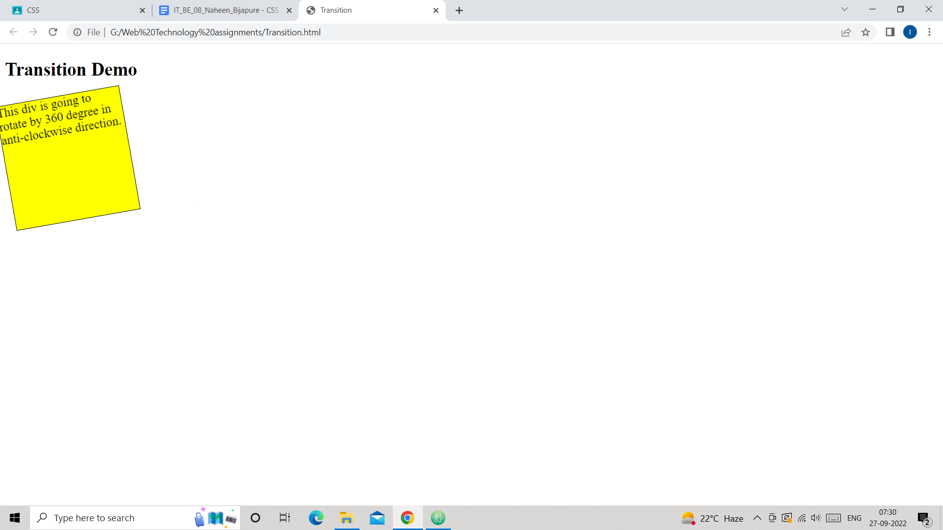

***Q5.Create at least 2 animation examples using CSS***

***Ans:***

***1)***

*<!DOCTYPE html>*

*<html lang="en" dir="ltr">*

*<head>*

*<meta charset="utf-8">*

*<title>Animation Demo-1</title>*

*<style media="screen">*

*div{*

*width:100px;*

*height:100px;*

*background-color:red;*

*border-radius:50%;*

*Animation-name:anime1;*

*animation-duration:4s;*

*animation-delay:1s;*

*}*

*@keyframes anime1{*

*0%{background-color:red;transform:rotate(45deg);}*

*25%{background-color:yellow;transform:rotate(45deg);}*

*50%{background-color:green;transform:rotate(45deg);}*

*100%{background-color:pink;transform:rotate(45deg);}*

*}*

*</style>*

*</head>*

*<body>*

*<h2>Circle Ratation:</h2>*

*<div></div>*

*</body>*

*</html>*

***Output:***

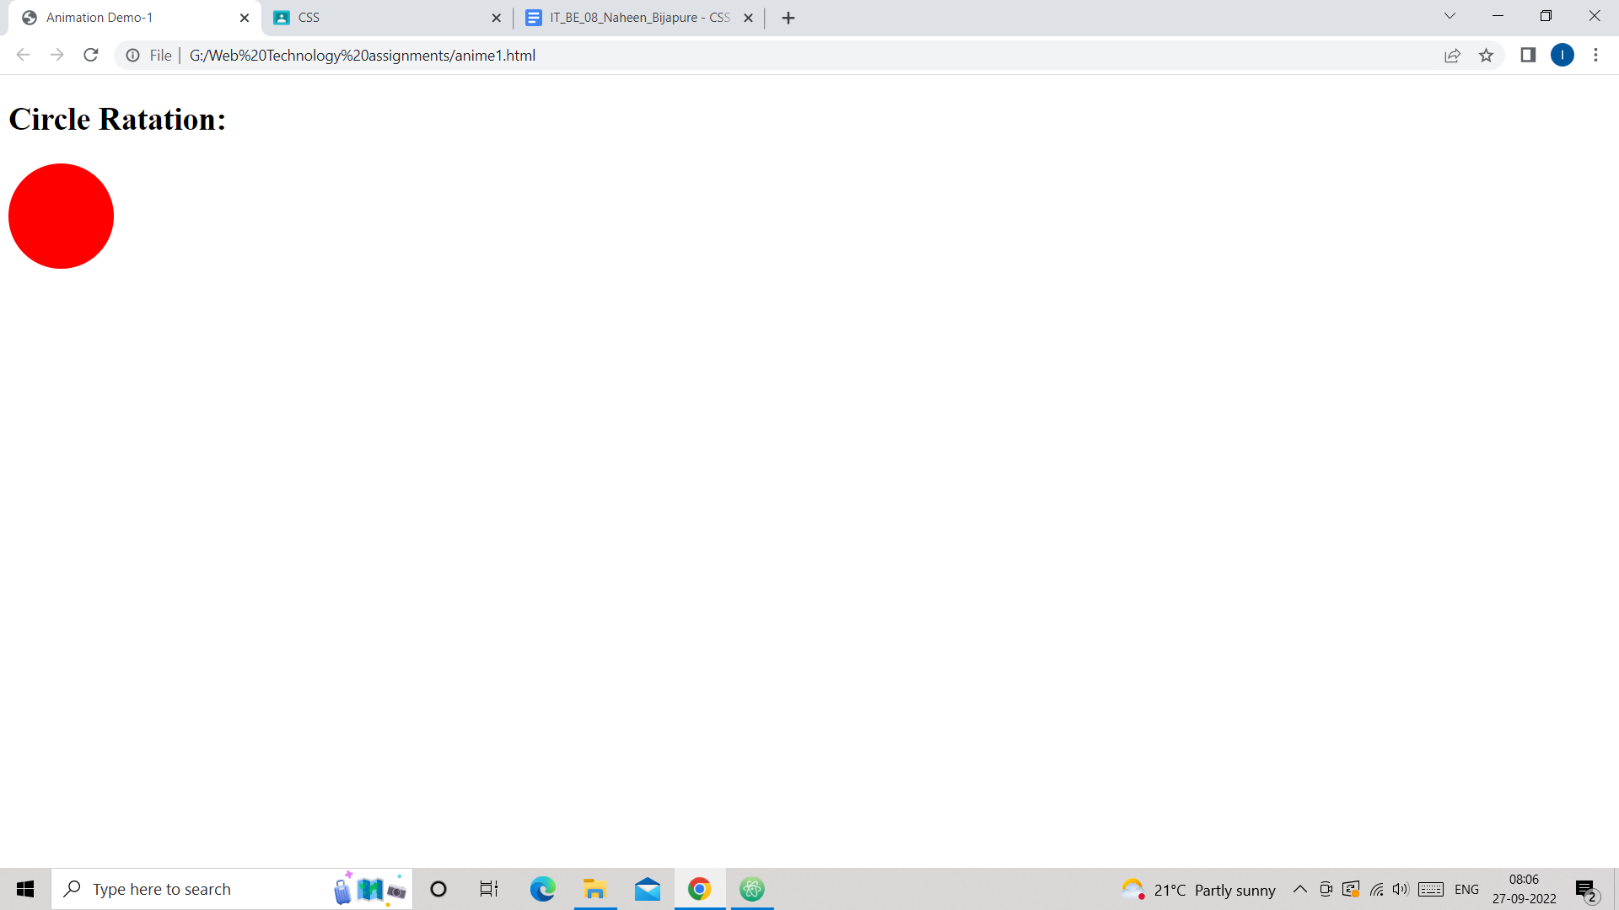

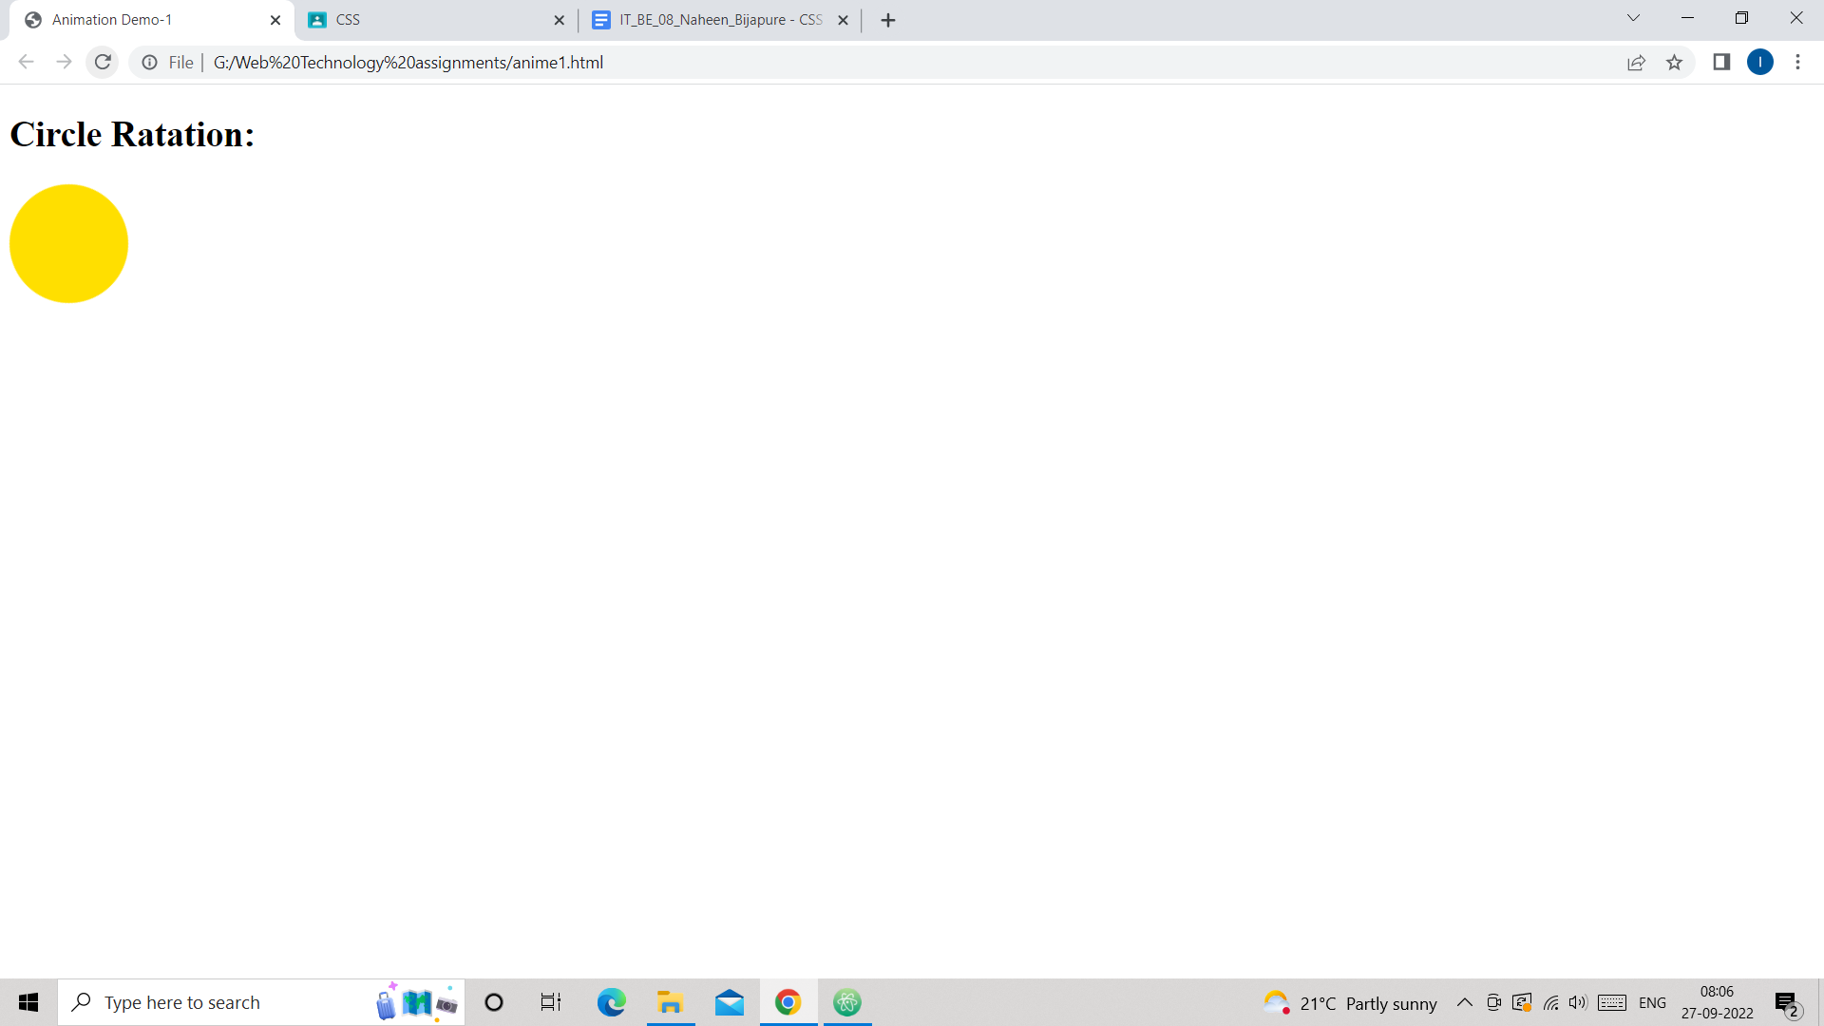

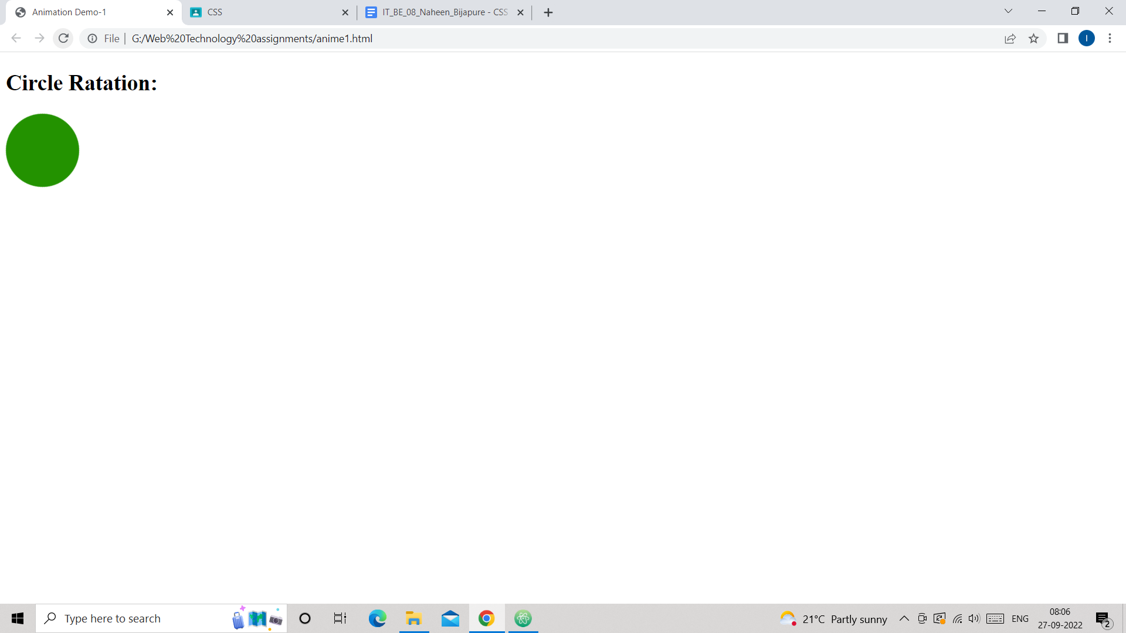

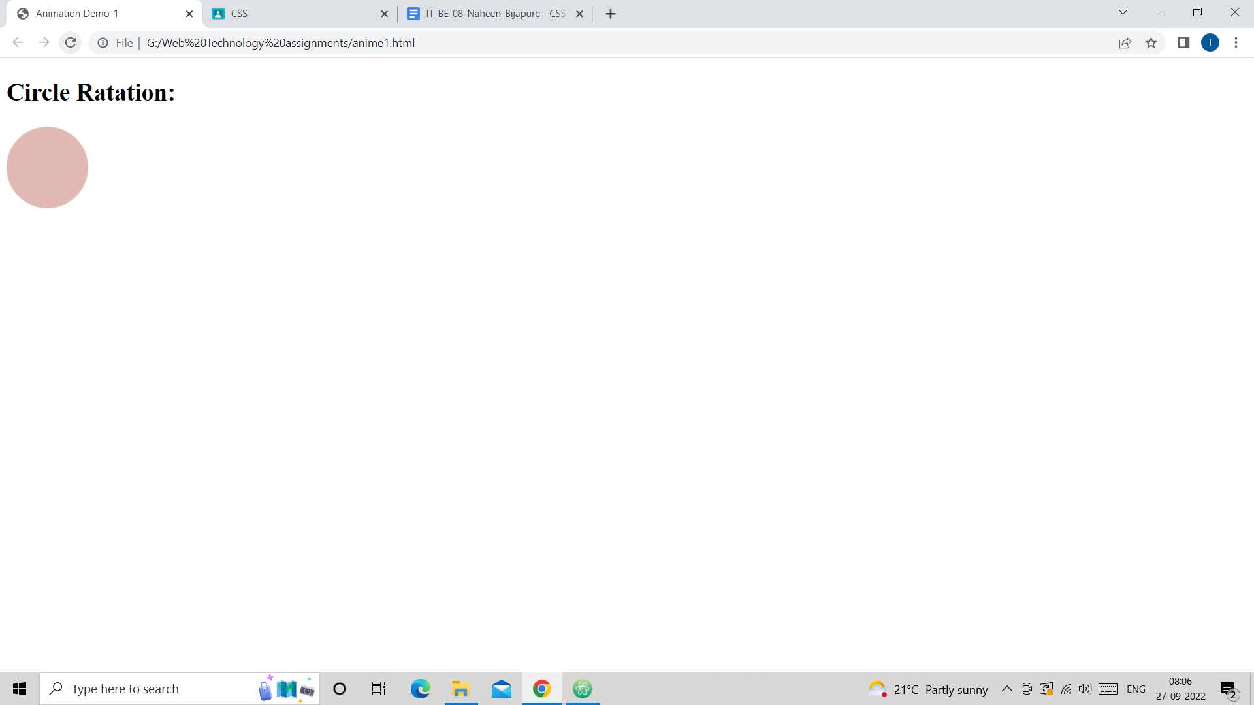

***2)***

*<!DOCTYPE html>*

*<html lang="en" dir="ltr">*

*<head>*

*<meta charset="utf-8">*

*<title>Animation Demo-2</title>*

*<style media="screen">*

*div{*

*width:200px;*

*height:200px;*

*background-color:yellow;*

*border-radius:50%;*

*Animation-name:anime2;*

*Animation-duration:4s;*

*Animation-iteration-count:2;*

*Animation-timing-function:linear;*

*position:relative;*

*}*

*@keyframes anime2{*

*0%{background-color:yellow;left:0px;top:0px;}*

*20%{background-color:red;left:500px;top:0px;}*

*40%{background-color:green;left:500px;top:200px;}*

*60%{background-color:purple;left:0px;top:200px;}*

*100%{background-color:yellow;left:0px;top:0px;}*

*}*

*</style>*

*</head>*

*<body>*

*<h2>Rotation Of Circle</h2>*

*<div>*

*</div>*

*</body>*

*</html>*

***Output:***



